
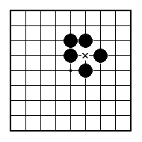
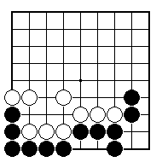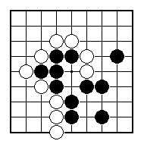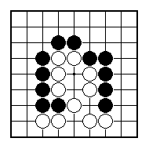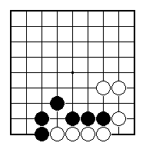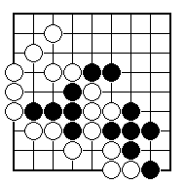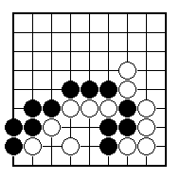
White to play and win some black stones.

White to play and win some black stones.

Black to sacrifice a stone to win some white ones.

Black to sacrifice a stone to win some white ones.

Black to sacrifice a stone to win some white ones.

Black to sacrifice a stone to win some white ones.

NAME:
BRITISH GO ASSOCIATION CERTIFICATE LEVEL 2 - SHEET 8

SCARIFICE TACTICS

